SIMATS ENGINEERING
ASSESSMENT TOOL 2 (LOW) - Industry Problem Solving Task

COURSE NAME: R PROGRAMMING COURSE CODE: ITA04
COURSE OUTCOME COVERED

CO2: Analyze datasets using Exploratory Data Analysis techniques including measures of central tendency, dispersion, bivariate analysis, and statistical tests such as T-test, ANOVA, and chi-square
(Bloom Level -BL4- BL5)

Assessment Tool Weightage: 25%

Code of Conduct:

I RAHIMA BANU N-192525009 (Name / Reg No) certify that this submission is my original work and that I have adhered to the guidelines specified for this assessment.
I understand that any violation of academic integrity rules will result in disciplinary action.

Signature of the student: RAHIMA BANU N

QUESTIONS: Total Marks: 100

Scenario
A retail company operates stores across multiple cities. The management has collected customer transaction data containing:
- Customer_ID
- Gender
- Age
- City
- Product_Category
- Purchase_Amount
- Monthly_Income
- Customer_Rating
- Membership_Status
- Store_Type
The company wants to improve customer satisfaction, optimize marketing strategies, and increase sales using data-driven decisions.

Question 1
The management wants to understand the overall spending behavior of customers. Calculate and interpret appropriate measures of central tendency (mean, median, and mode) for Purchase Amount. Based on the results, recommend which measure best represents customer spending patterns.

Question 2
Analyze the variability in customer spending using measures of dispersion such as range, variance, standard deviation, and interquartile range. Identify whether spending behavior is consistent across customers and justify your findings.

Question 1-

Objective
To analyze the overall spending behavior of customers by calculating the mean, median, and mode of the Purchase Amount and identify the most appropriate measure of central tendency.
R Code:

# Create Sample Dataset
set.seed(123)
retail <- data.frame(
Customer_ID = 1:100,
Gender = sample(c("Male","Female"),100,replace=TRUE),
Age = sample(18:60,100,replace=TRUE),
City = sample(c("Chennai","Bangalore","Hyderabad","Mumbai"),100,replace=TRUE),
Product_Category = sample(c("Electronics","Clothing","Grocery","Furniture"),100,replace=TRUE),
Purchase_Amount = sample(seq(1000,10000,500),100,replace=TRUE),
Monthly_Income = sample(seq(20000,100000,5000),100,replace=TRUE),
Customer_Rating = round(runif(100,3,5),1),
Membership_Status = sample(c("Premium","Regular"),100,replace=TRUE),
Store_Type = sample(c("Urban","Semi-Urban","Rural"),100,replace=TRUE)
)
mean(retail$Purchase_Amount)
median(retail$Purchase_Amount)
Mode <- function(x){
ux <- unique(x)
ux[which.max(tabulate(match(x,ux)))]
}
Mode(retail$Purchase_Amount)

OUTPUT:

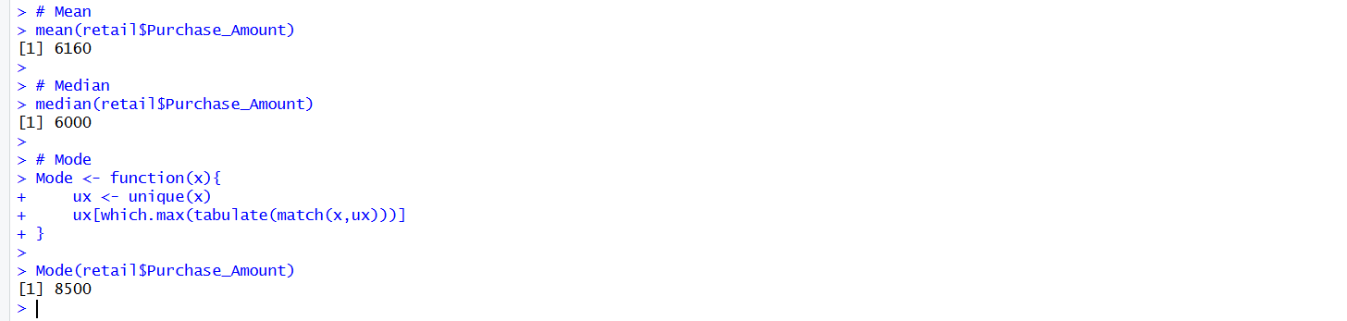

Question 2-

Objective
To analyze the variability in customer spending using measures of dispersion such as Range, Variance, Standard Deviation, and Interquartile Range (IQR) and determine whether customer spending is consistent.

R Code
# Range
range(retail$Purchase_Amount)
# Variance
var(retail$Purchase_Amount)
# Standard Deviation
sd(retail$Purchase_Amount)
# Interquartile Range
IQR(retail$Purchase_Amount)

OUTPUT:

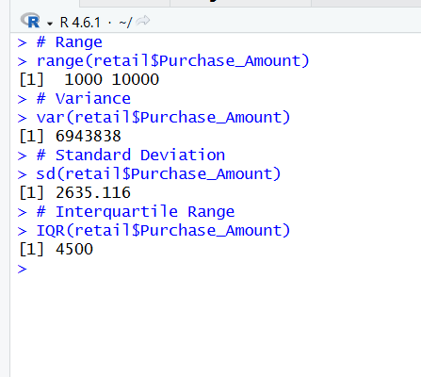

RUBRICS FOR CALCULATION

Industry Problem Solving Task
Criteria | Weightage | Level 4 – Exemplary | Level 3 – Proficient | Level 2 – Developing | Level 1 – Beginning
Application of EDA Techniques | 25 | Correctly applies central tendency, dispersion, and bivariate analysis techniques. | Applies most EDA techniques correctly with minor omissions. | Applies basic EDA techniques with limited accuracy. | Demonstrates limited or incorrect application of EDA techniques.
Statistical Analysis & Testing | 25 | Correctly performs and interprets T-test, ANOVA, and Chi-square analysis. | Performs statistical tests with minor interpretation errors. | Performs basic statistical analysis with limited interpretation. | Demonstrates poor understanding of statistical tests.
Problem Analysis & Data Interpretation | 20 | Accurately analyzes data patterns and derives meaningful insights. | Provides reasonable analysis with adequate interpretation. | Provides limited analysis and interpretation. | Analysis is weak or incorrect.
Decision-Making & Business Recommendations | 20 | Provides data-driven recommendations that effectively address the business problem. | Recommendations are relevant and supported by analysis. | Recommendations are basic with limited justification. | Recommendations are weak, unsupported, or missing.
Organization & Completeness | 10 | Response is well-structured, complete, and addresses all requirements. | Mostly complete and organized. | Partially complete with some missing components. | Incomplete and poorly organized.

